|  |  |  |  |
| --- | --- | --- | --- |
| HIGH LEVEL DESIGN DOCUMENT  PerfectCrop-The right crop for your soil  UE18CS390A – Capstone Project Phase – 1  ***Submitted by:***   |  |  | | --- | --- | | **Srish Srinivasan**  **Akash Kumar Rao**  **Vishruth P Reddy**  **Ishan Agarwal** | **PES1201800051**  **PES1201800089**  **PES1201800102**  **PES1201800291** |   Under the guidance of   |  | | --- | | **Prof. Raghu B A**  Associate Professor  PES University |   **January - May 2021**  **DEPARTMENT OF COMPUTER SCIENCE AND ENGINEERING**  FACULTY OF ENGINEERING  **PES UNIVERSITY**  (Established under Karnataka Act No. 16 of 2013)  100ft Ring Road, Bengaluru – 560 085, Karnataka, India |

TABLE OF CONTENTS

|  |  |
| --- | --- |
| 1. Introduction | 4 |
| 1. Current System | 4 |
| 1. Design Considerations | 4 |
| 3.1 Design Goals | 4 |
| 3.2 Architecture Choices | 5 |
| 3.3 Constraints, Assumptions and Dependencies | 5 |
| 1. High Level System Design | 6 |
| 1. Design Description | 7 |
| * 1. Master Class Diagram | 7 |
| 5.2 Reusability Considerations | 7 |
| 1. ER Diagram / Swimlane Diagram / State Diagram | 8 |
| 1. User Interface Diagrams | 10 |
| 1. Report Layouts | 10 |
| 1. External Interfaces | 10 |
| 1. Packaging and Deployment Diagram | 10 |
| 1. Help | 10 |
| 1. Design Details | 11 |
| 12.1 Novelty | 11 |
| 12.2 Innovativeness | 11 |
| 12.3 Interoperability | 11 |
| 12.4 Performance | 11 |
| 12.5 Security | 11 |
| 12.6 Reliability | 11 |
| 12.7 Maintainability | 12 |
| 12.8 Portability | 12 |
| 12.9 Legacy to Modernization | - |
| 12.10 Reusability | - |
| 12.11 Application Compatibility | 12 |
| 12.12 Resource Utilization | 12 |
| Appendix A: Definitions, Acronyms and Abbreviations | 12 |
| Appendix C: Record of Change History | 13 |
| Appendix D: Traceability Matrix | 13 |
|  |  |

# Note:

|  |  |
| --- | --- |
| **Section – 1 & Section 2** | **Common for Product Based and Research Projects** |
| **Section 3 to Section 11** | **High-Level Design for Product Based Projects.** |
| **Section 12** | **High-Level Design for Research Projects.** |
| **Appendix** | **Provide details appropriately** |

# Introduction

The main goal of our project is to predict the most suitable crop to a farmer or a horticulturist based on the atmospheric and soil parameter values that are entered in the mobile or web application. This document gives a detailed description of our mobile and web application and the machine learning models being used to predict the right crops.

# Current System

On reading literature surveys that are relevant to our problem statement, we understand that some of the common machine learning techniques that have been employed are logistic regression, support vector machines, naive bayes classifier, and decision trees. Therefore, we will make an attempt to implement other machine learning algorithms that have been left out and also try and incorporate other advanced algorithms such as ensemble models, artificial neural networks bagging and boosting.

1. **Design Considerations** 
   1. **Design Goals**

* The existing applications require the farmer to create an account using email IDs and by providing card details.
* Some applications even charge for using their product.
* Our application is very simple as we do not collect any personal information from the user. All they have to do is enter their phone number and create a password.
* Once they are logged in, all that farmer has to do is to just input the soil and atmospheric details and let the machine learning models do their job.
* No payment or addition of personal details is required.
* We respect the privacy of our users so we do not collect any personal details. They can use the app directly by just using their phone number to login once and use it indefinitely until they logout..
* Since we aren’t collecting any personal information like name, age, salary, card details and other details like farm location or farm ID, so security is also maintained.
* It can be easily downloaded as it is a small application and needs only a minimum of 4GB RAM which is available in almost all the smartphones.
* As soon as the user enters all the values asked for, the application immediately starts to process the data and predicts the perfect crop within a few seconds.
  1. **Architecture Choices**

One way was to use the NPK sensors to get the N, P and K contents from the soil. These details would either be displayed using a 7-segment display or it could be displayed directly into the users mobile application. The model used to extract the soil details would have been robust but the problem was that a crop is not only dependent on Nitrogen, Phosphorus and Potassium but other elements such as Iron, Copper, Manganese, Magnesium etc. All these elements along with fertilizers, insecticides, pesticides and water supply matter a lot when it comes to growing a particular crop. So the simple NPK sensor can’t determine the ideal crop to be grown.

Our application gives the user the flexibility of inserting the values of not only the N, P and K values but also other elements like pH value of soil, Fe, Mn, Mg, Zn, Cu, Ca etc. They also need to enter other parameters like average rainfall, humidity and temperature range of that location. After adding the necessary values, all they have to do is click the submit button and wait for the application to display all the possible crops that can be grown along with their yield percentage.

# Constraints, Assumptions and Dependencies

* Interoperability requirements
  + There are no interoperability requirements in our project.
* Interface/protocol requirements
  + All that is necessary is the mobile or the web application to add the soil and atmospheric data.
* Data repository and distribution requirements
  + All the soil and atmospheric details added by users will be stored in the firebase for training the models and improving their predictive capacity.
* Discuss the performance related issues as relevant.
  + There will not be any platform related issues as it is a very simple application and easy to operate.
* End-user environment.
  + In the end-user environment, the output of the prediction will be very clear and self explanatory. It needs no technical knowledge.
* Hardware or software environment
  + There is no hardware component for our project.
  + The software component will be the mobile or web application that the users will use for prediction.

# High Level System Design

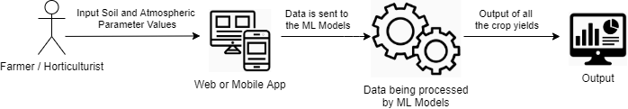

# Design Description

* 1. **Master Class Diagram**

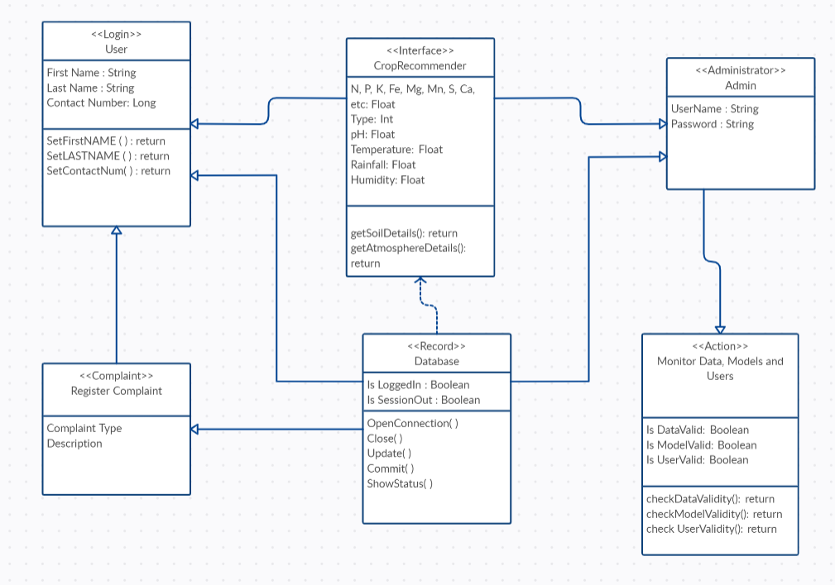

* 1. **Reusability Considerations**
* The machine learning models that will be built in order to make crop recommendations are built using the scikit learn API which happens to be the reusable component in the project.
* The web application and android mobile application that we will be building from scratch will be the non-reusable components of the project.

1. **ER Diagram**

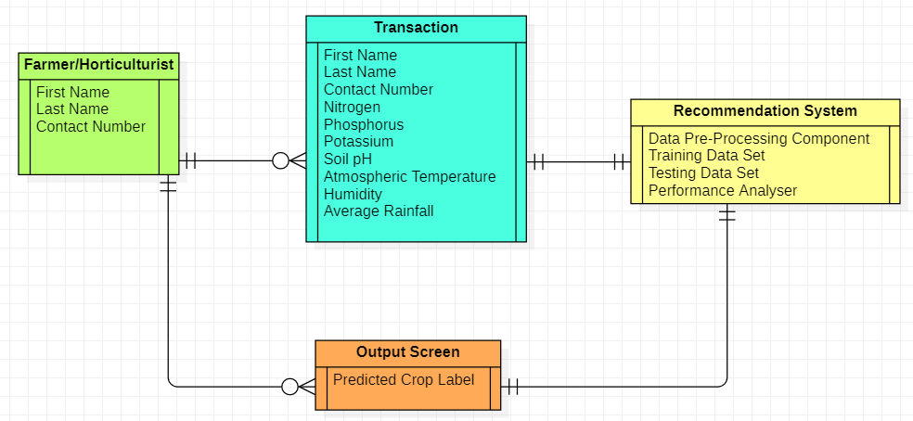

|  |  |  |  |  |
| --- | --- | --- | --- | --- |
| **#** | **Entity** | **Name** | **Definition** | **Type** |
| **ENTITIES** | | | | |
|  | Client | Farmer/ Horticulturist | The person making use of our application. | Strong |
|  | Database | Transactions | Details provided by the user. | Strong |
| 3. | Server | Recommendation System | Data processing is done and the predicted crop is being generated. | Strong |
| 4. | Output | Output Screen | The predicted crop is being displayed. | Strong |
| **#** | **Attribute** | **Name** | **Definition** | **Type (size)** |
| **DATA ELEMENTS** | | | | |
|  | Client | First Name | Provide the first name of the user. | String |
|  |  | Last Name | Provide the last name of the user. | String |
| 3. |  | Contact Number | Provide the phone number of the user. | Long |
| 4. | Database | N,P,K,Ca,Mg etc | Salts present in the soil. | Float |
| 5. |  | pH | Provide the acidic or alkaline contents of the soil. | Float |
| 6. |  | Temperature | Provide the atmospheric temperature. | Float |
| 7. |  | Humidity | Provide the atmospheric humidity. | Float |
| 8. |  | Rainfall | Provide the annual/seasonal average rainfall. | Float |
| 9. | Server | Data pre-processing | Input data is processed. | - |
| 10. |  | Training phase | 70% of the data is trained. | - |
| 11. |  | Testing phase | 30% of the data is tested. | - |
| 12. |  | Performance Analyzer | Provides the accuracy score. | - |
| 13. | Output | Output Screen | Shows the final output of the predicted crop. | String |

1. **User Interface Diagrams**

The UI of the system is kept as minimal as possible with no unnecessary Log-In, Sign-Up implementation and recording farmer’s data. The farmer shall simply open the website, fill in the soil and location details, hit the submit button and will be presented with our algorithm’s best options.

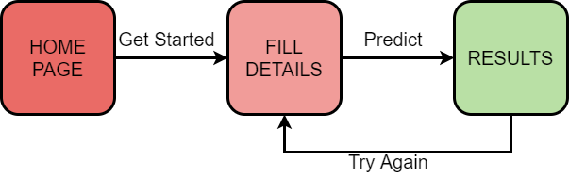

1. **Report Layouts**

Not Applicable.

1. **External Interfaces**

Please refer to **4.** **High Level System Design, page 6.**

1. **Packaging and Deployment Diagram**

Not Applicable.

# Help

Since the targeted audience for this project comprises mostly farmers from rural as well as urban backgrounds, a User Manual describing the usage of the product becomes very essential which must not be limited by any sorts of language or financial barriers. Thus a detailed video guide explaining the usage must be made along with written guides in several regional languages.

1. **Design Details**
   1. **Novelty**

The problem statement that we are solving here is not new and a few solutions

have already been built in the past. But the difference in the approaches arises due to the different machine learning algorithms that have been employed to solve the problem. We will be focusing on a few machine learning algorithms, ensemble learning algorithms and artificial neural networks.

* 1. **Innovativeness**

Weplan to incorporate innovativeness into our project by employing the most accurate machine learning technique and at the trying to minimize any computational overhead to the greatest extent possible. Our goal is also to make the user interface extremely simple and user friendly .

* 1. **Interoperability**

We will be ensuring that the exchange of information between the machine learning models and the web application/mobile application is extremely smooth and quick.

* 1. **Performance**

We will be making sure that both the mobile and web applications will be functioning very efficiently and thereby producing the required results in quick time.

* 1. **Security**

The application requires a very minimal set of user data, which includes First Name, Last Name, and Contact Number. We will make sure that the user data is stored in an encrypted format and is denied access to any other person apart from the user himself.

* 1. **Reliability**

We will make sure that the results generated by the application are very reliable by making use of extremely reliable data in order to build and train the machine learning models.

* 1. **Maintainability**

We will be designing our application in a modular approach. Once every component of the application is a module in itself, then the application becomes very maintenance friendly and in the case of any modifications or additions, their implementations can be integrated with the existing application with absolute ease.

* 1. **Portability**

Our application could be used both on PCs as well as android smartphones. Therefore, our application is very portable

* 1. **Application compatibility**

Our application will be compatible on all android smartphones that have a minimum of 4 GB of RAM, a 5.5 inch display and good quality network connection. Similarly, it is compatible on all Windows PCs having a minimum of 4 GB of RAM and a good quality network connection.

* 1. **Resource utilization**

We will make sure that our application is lightweight and makes use of the compute resources in an efficient manner.

**Appendix A: Definitions, Acronyms and Abbreviations**

N: Nitrogen Fe: Iron UI: User Interface

P: Phosphorus Ca: Calcium PC: Personal Computer

K: Potassium Mg: Magnesium

pH: power of Hydrogen Mn: Manganese

GB: Gigabyte S: Sulphur

RAM: Random Access Memory

# Appendix C: Record of Change History

|  |  |  |  |  |
| --- | --- | --- | --- | --- |
| **#** | **Date** | **Document Version No.** | **Change Description** | **Reason for Change** |
|  | **12/04/2021** | **1** | - | **-** |
|  |  |  |  |  |
|  |  |  |  |  |

# Appendix D: Traceability Matrix

[Demonstrate the forward and backward traceability of the system to the functional and non-functional requirements documented in the Requirements Document.]

|  |  |
| --- | --- |
| **Project Requirement Specification Reference Section No. and Name.** | **DESIGN / HLD Reference Section No. and Name.** |
| Section 3, Functional Requirements | Section 3.1, Design Goals |
| Section 5.1, Performance Requirements | Section 12 k, Design Details |
| Section 5.2, Security Requirements | Section 12 e, Security |